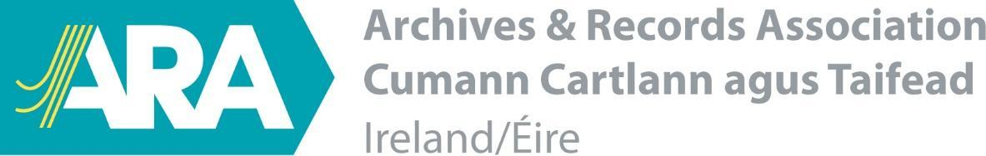

Statement on the Commission of Investigation (Mother and Baby Homes and certain related Matters) Records, and another Matter, Bill 2020

The Archives and Records Association, Ireland (ARA, Ireland) is the principal professional body for archivists, conservators and records managers in Ireland. We wish to express our concern around the lack of consultation, consideration and inclusivity in passing the Commission of Investigation (Mother and Baby Homes and certain related Matters) Records, and another Matter, Bill, 2020.
We welcome the government's subsequent acknowledgement of the hurt this has caused to victims and survivors of abuse, and its commitment to working with the Data Protection Commission and other legal experts in relation to accessibility. We also welcome further reference to management and preservation of the records of the Commission. However, we feel this continues to fall short in terms of addressing concerns around access and information governance, archives and records management, data protection and digital preservation of the archive of the Mother and Baby Homes Commission of Investigation and associated database.
ARA, Ireland, therefore calls for a fundamental review of this Bill and proposed new measures in relation to the National Archives Act, 1986, National Archives (Amendment) Act, 2018, Data Protection Act, 2018 and other associated legislation, in consultation with stakeholders including the National Archives and wider archival community in Ireland. We would urge further consideration on a wide range of unresolved issues, including concerns around the allocation of responsibility for managing the MBH Commission of Investigation database to the Child and Family State Agency, TUSLA. TUSLA, established on the 1st January 2014, is not subject to the National Archives Act, 1986, and is among over 150 publicly-funded State bodies with no legal requirement to maintain and archive their records for release to the public under the 30 year rule. Although this MBH Commission of Investigation database is protected under the provisions of the National Archives Act, 1986, TUSLA will continue to have no legal protection for its own records, including those associated with this database, or have any legal requirement to transfer its records to the National Archives for their release to the public for consultation. Furthermore, the absence of any standardised approach to records management across the civil and public service demonstrates the need for a review of National Archives legislation, including expansion of the scope of the legislation and a statutory role for the National Archives in the oversight of record keeping across the civil and public service.

On this basis, we urge the Minister for Children, Equality, Disability, Integration and Youth to engage in further dialogue with survivors of abuse and their representatives, as well as with the National Archives, Ireland; the National Archives Advisory Council; the Minister for Media, Tourism, Arts, Culture, Sport and the Gaeltacht, who has statutory responsibility for the National Archives; and the Minister for Department of Public Expenditure and Reform, who has statutory responsibility for records management across the civil and public service.
This is a defining moment for the State in its treatment of survivors of abuse. It is vital that access, management and preservation of their testimony and the important records and work of the Commission are considered at greater length, so that those most directly impacted are supported, and society and future generations can attest to this period in our history.

